Chapter 6, Problem 46.

Find v_{C}, i_{L}, and the energy stored in the capacitor and inductor in the circuit of Fig. 6.69 under dc conditions.

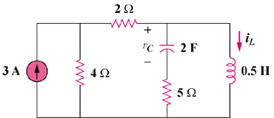

Figure 6.69
For Prob. 6.46.

